BUSINESS INTELLIGENCE
DATA MODELLING



KHEN MUHAMMAD CAHYO
244107023002
TI-3I
STATE POLYTECHNIC OF MALANG
INFORMATION TECHNOLOGY DEPARTMENT

TASK NUMBER 1 – CREATE DATABASE toko_maju
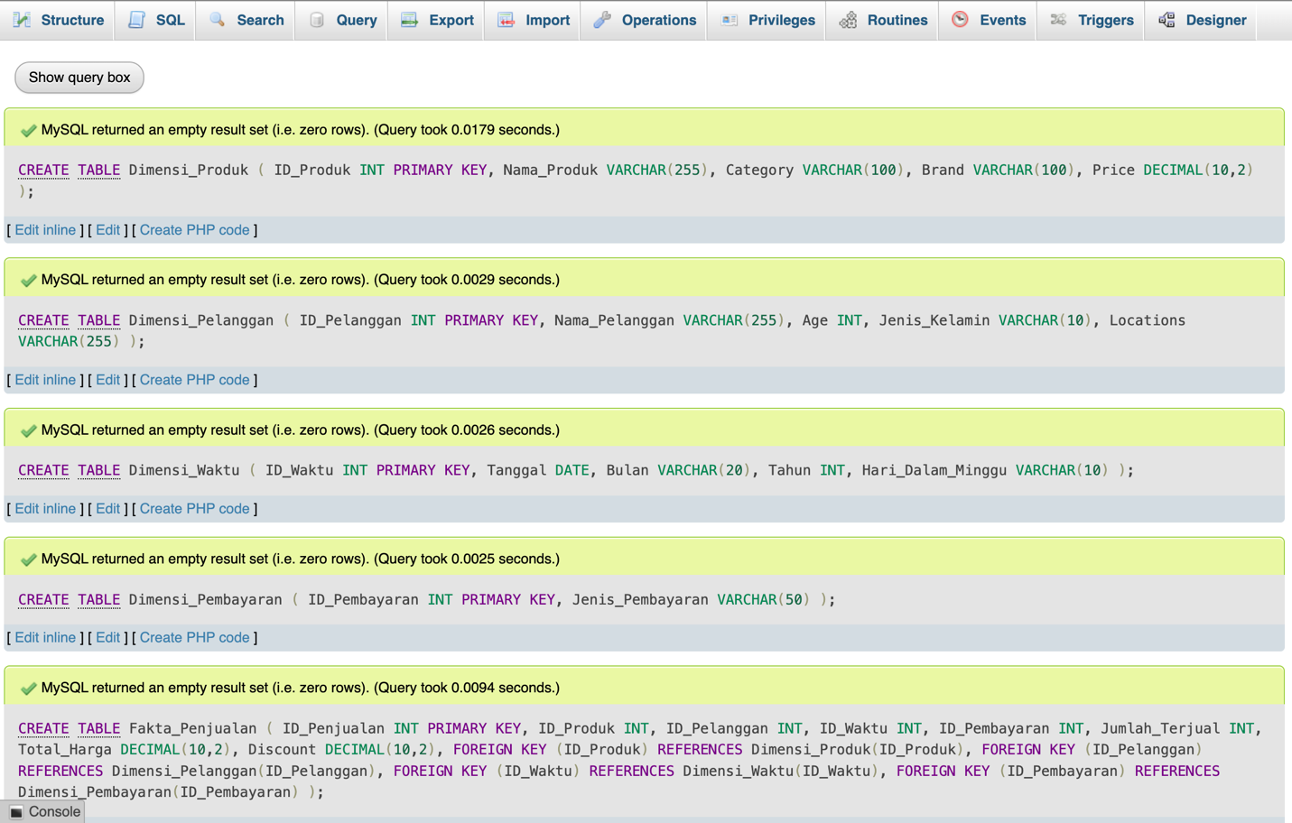
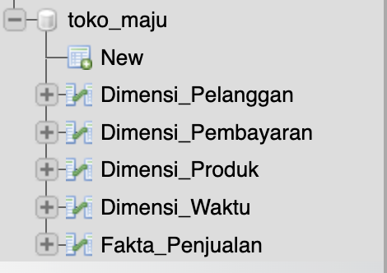

TASK NUMBER 2 – ENTER A DATA ON EACH TABLE
- Insert Into Dimensi Pembayaran
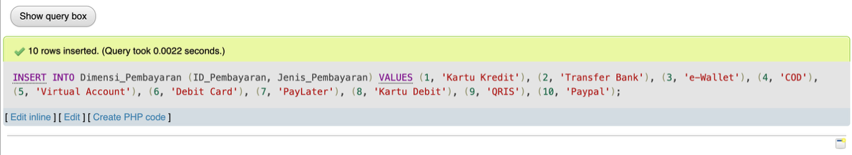
- Insert Into Dimensi Pelanggan
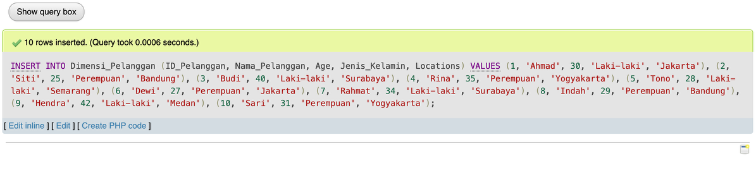
- Insert Into Dimensi Produk
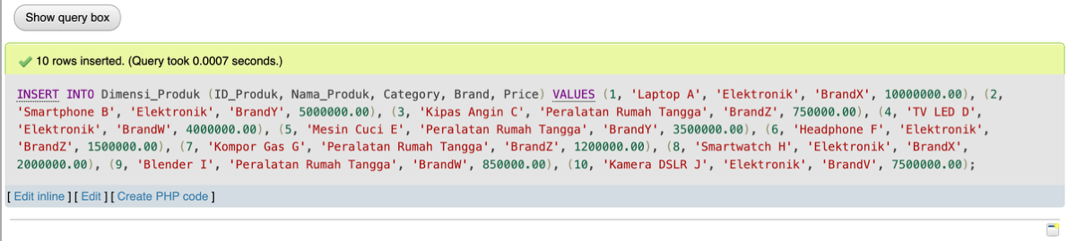
- Insert Into Dimensi Waktu
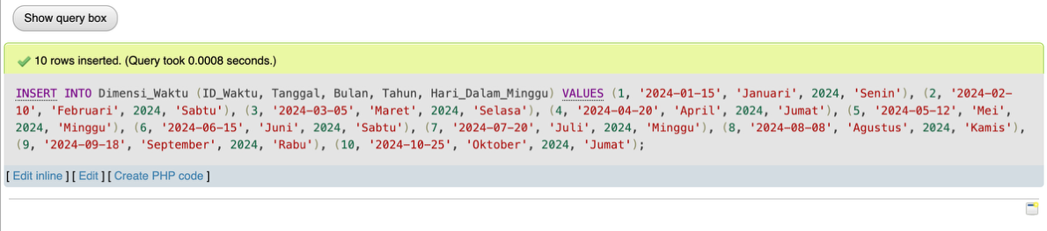
- Insert Into Fakta Penjualan
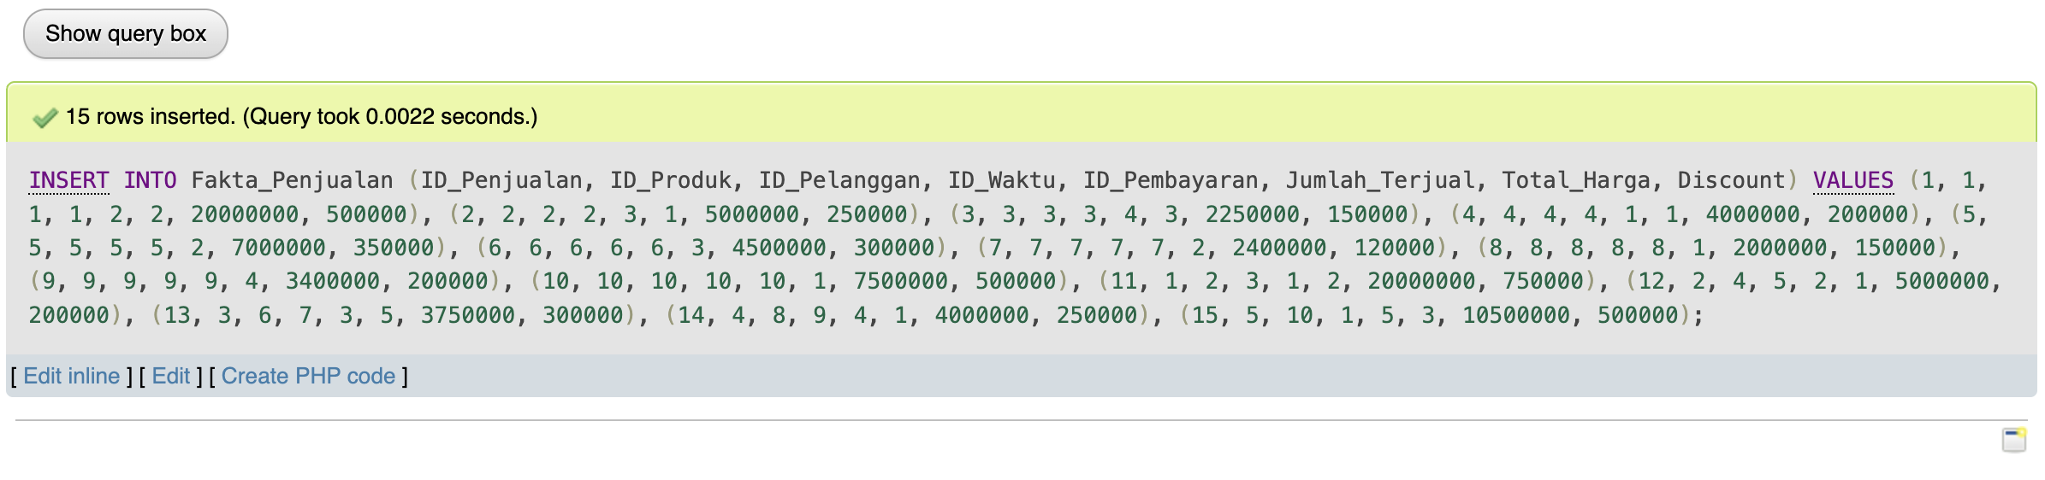

TASK NUMBER 3 – DATA ANALYSIS QUERIES EXAMPLE
- Total Sales per Product Category
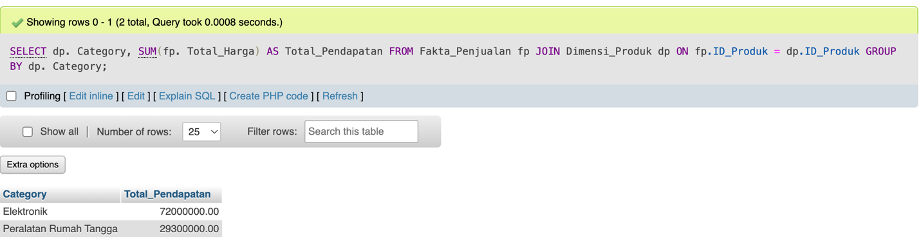
- Number of Transactions per Payment Method
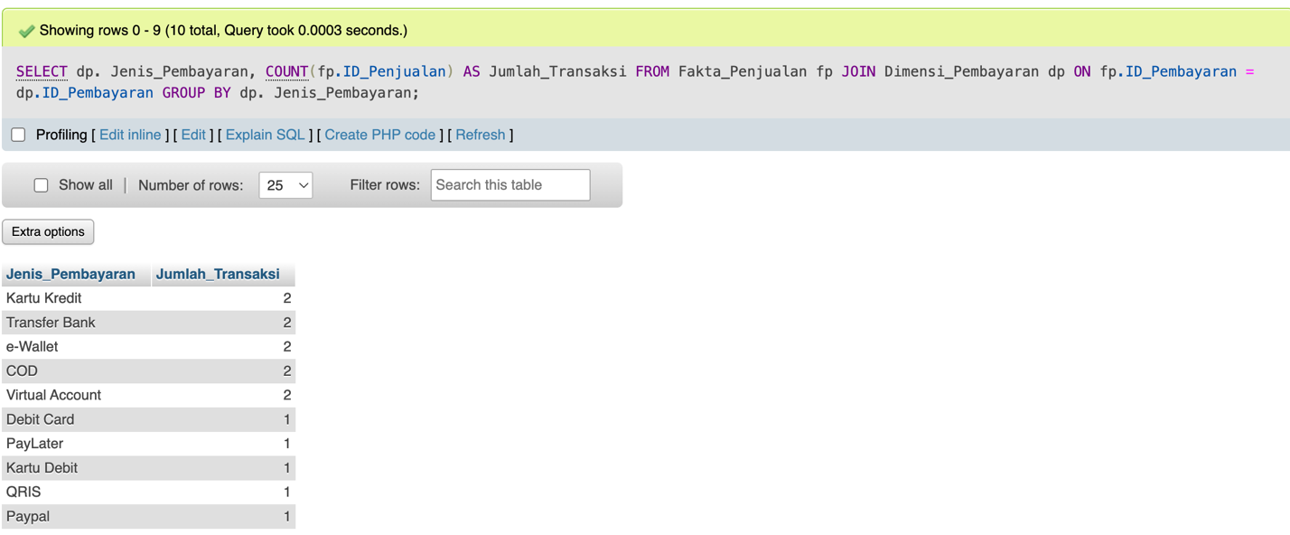
- Monthly Sales Trends in 2024
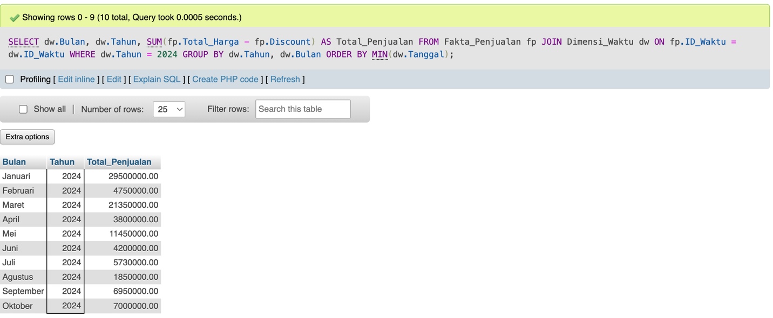

- Total Sales per Month
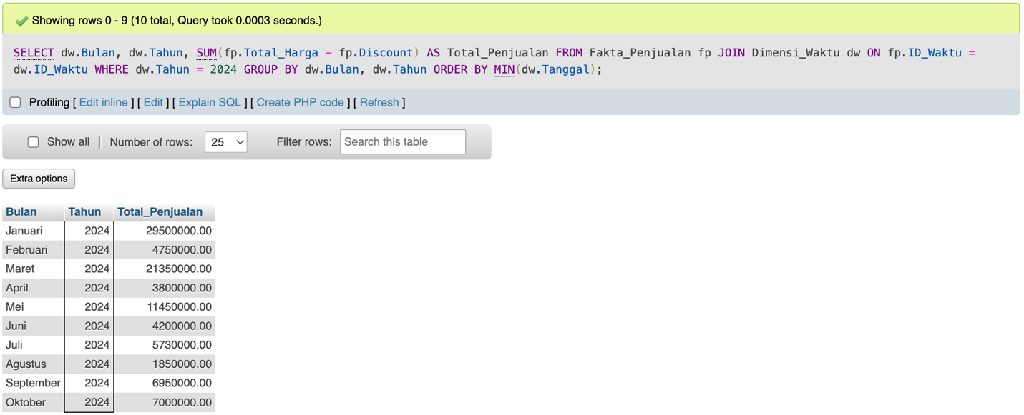
- Product Categories with the Most Sales
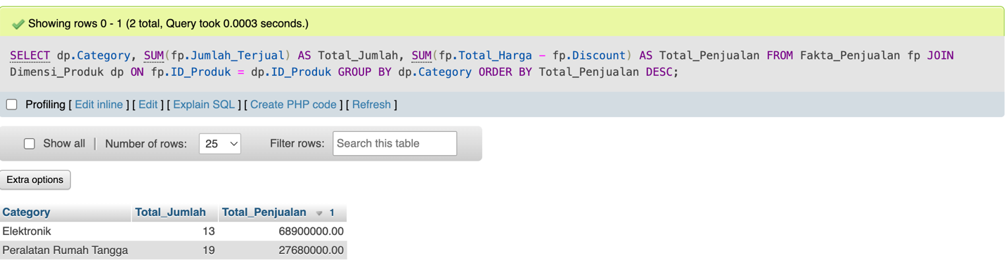
- Most Frequently Used Payment Methods
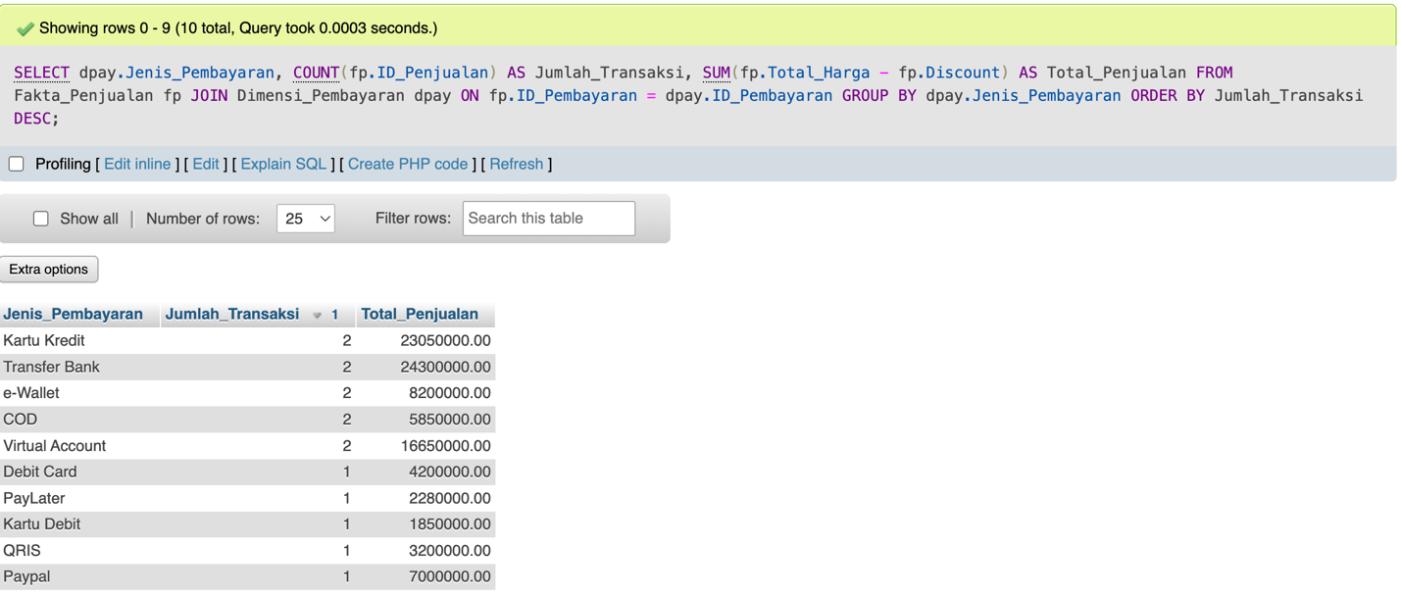

- Customers with the Highest Total Purchases
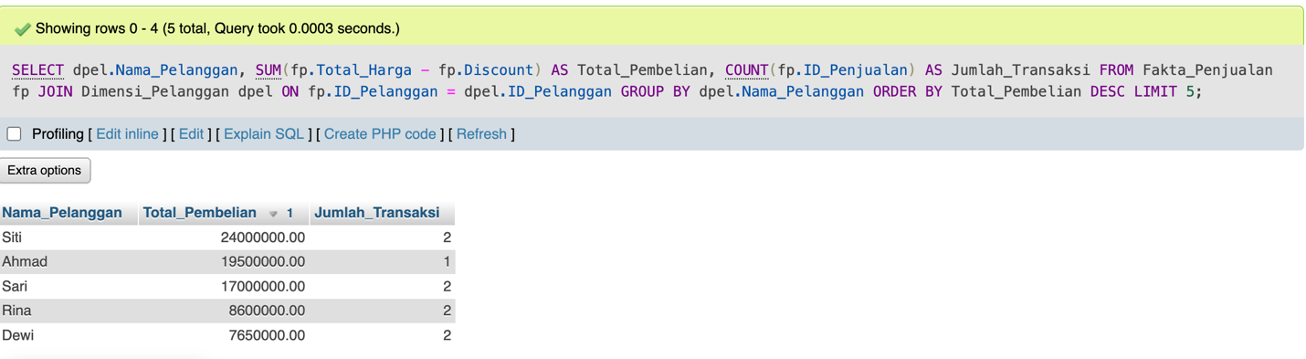
TASK NUMBER 4 – CONCLUSION
Based on the results of the lab work, we successfully built a simple data warehouse with dimension tables (product, customer, time, payment) and a sales fact table. The analysis query reveals that monthly sales trends in 2024 were quite varied, with a peak in January (Rp 29,500,000) and a decline in August (Rp 1,850,000). Product category analysis shows that the Electronics category generated the largest total sales, while the Household Appliances category outperformed in terms of units sold. In terms of payment methods, no single method was dominant, but Bank Transfer, Credit Card, e-Wallet, Cash on Delivery (COD), and Virtual Account emerged as the most frequently used methods.
Furthermore, customer analysis shows that several customers are key contributors to total purchases, such as Siti, Ahmad, and Sari, who account for large transactions. This underscores the importance of applying multidimensional analysis to understand consumer behavior, sales patterns, and the effectiveness of payment methods. With this approach, companies can more easily make strategic decisions, such as determining marketing strategies, providing special offers to potential customers, and optimizing the most popular payment methods.

